**Introduction to Text and Sequencing**

**Understanding Text and Sequencing**

Text and sequencing refer to several methods of managing and examining textual information while keeping a careful eye on the word order. This method is crucial since a text's meaning and interpretation can be greatly influenced by the way its words are arranged. For example, comprehending the context and relationships between words in natural language processing tasks like sentiment analysis or machine translation frequently necessitates considering the sequential patterns in which they occur. Because of this, analysts can derive deeper interpretations from the data and extract more precise insights by maintaining the text's sequential pattern.

**What is Sentiment Analysis:**

The importance of language and sequencing is especially clear in sentiment analysis. This assignment entails determining if a text's sentiment is neutral, positive, or negative. The overall sentiment is greatly influenced by the words that appear in what order. Think about the terms "good" and "not good," for example. Even though they both use the term "good," their meanings are different. “good” denotes positivity, whereas "not good" introduces negation and engenders a negative feeling. As a result, correctly interpreting sentiment analysis necessitates not just word identification but also comprehension of word sequence and context within the text. Sentiment analysis algorithms can effectively discern the sentiment conveyed in a text by considering the word order in a sequential fashion.

**Approach:**

In our project, we adopt sophisticated machine learning models capable of comprehending and interpreting sequential patterns inherent in textual data. This methodology entails:

• Text Preparation: transforming unstructured text into a format that is appropriate for our machine learning algorithms. To help the models analyze the textual data efficiently, this generally entails converting sentences into numerical representations, where each number corresponds to a different word.   
  
• Making Use of Pattern-Recognition Models: Making use of sophisticated algorithms like LSTM (Long Short-Term Memory), which are designed to remember and interpret the word order of a sentence. Because of its built-in architecture, LSTM can record the complex relationships between words, which makes it easier to understand the underlying semantics and context in more detail. Our method leverages these models to improve sentiment analysis and other text-related tasks' accuracy and efficacy.

**Summary and Applications of Deep Learning Techniques:**

In our study, we used the IMDB dataset to do sentiment analysis using deep learning algorithms. This is an overview of our strategy and the main techniques we used:   
  
• Data Preparation: To enable efficient model training and assessment, we divided the dataset into separate sets for training, validation, and testing.   
  
• Text Vectorization: We transformed textual input into numerical representations that neural networks could analyze by utilizing TensorFlow's Text Vectorization feature. We set up the settings to account for differences in sequence length and vocabulary size.   
  
• Embedding: Using both bespoke and pre-trained GloVe embeddings, we examined several embedding methods. This method improved our models' comprehension of the subtleties found in reviews by enabling them to effectively capture the semantic meanings of words.

• Recurrent Neural Networks (RNNs): To take use of text sequences' past and future context, bidirectional LSTMs were used. This reciprocal method was essential to understanding the many linguistic nuances found in the reviews.   
  
• Model Training and Evaluation: We iteratively trained our models, tweaking their architecture and parameters to reduce overfitting and increase accuracy.   
  
We sought to create strong sentiment analysis models that could reliably identify the sentiment represented in IMDB reviews by methodically implementing these deep learning techniques.

**How to Increasing Model Accuracy?**    
  
• Greater Training Data: One interesting finding was that a larger training dataset significantly improved model accuracy. Our models first had low accuracy due to difficulties with generalization on smaller datasets. But as we increased the dataset—from 100 samples to 7100, and then to 14100—we noticed a notable increase in test and validation accuracies. This pattern emphasizes how important large datasets are for deep learning model training. Bigger datasets provide a more thorough portrayal of the various subtleties in human language, which helps the model learn and generalize more efficiently.

• Model Adjustments: Increasing the model's architecture and adjusting its parameters—such as the amount of LSTM units, dropout rates, and the inclusion of bidirectional layers—was another important factor in the increased accuracy. These modifications were crucial in allowing our models to detect complex patterns in the data while reducing the possibility of overfitting. Through the optimization of these parameters, we made sure that our models could better identify and understand intricate language aspects, which improved overall performance.

**Conclusion:**

• Data Volume and Model Complexity: To maximize performance, our findings highlight the crucial interaction between the amount of training data and the model's architectural complexity. Bigger datasets allow the model to be exposed to a wider range of moods and textual expressions, which promotes strong learning and generalization. Simultaneously, sophisticated model features like embeddings and bidirectional LSTMs improve the model's capacity to process and understand this data, which improves performance even more.   
  
• Continuous Refinement: To achieve optimal results, our findings highlight the iterative aspect of both dataset growth and model refinement. We iteratively refined our models to conform to the many subtleties present in natural language processing tasks by gradually expanding the dataset size and modifying model configurations. This iterative refinement process is pivotal in ensuring that the model evolves alongside the evolving complexities of textual data, ultimately yielding superior performance.

**Results:**

|  |  |  |  |  |
| --- | --- | --- | --- | --- |
| Model Configuration | Training Samples | Validation Accuracy | Test Accuracy | Loss |
| Sequence model along embedding layer | 100 | 51.46% | 51.42% | 0.7372 |
| Sequence model with pre-trained embedded layer (GLoVe) | 100 | 53.64% | 53.69% | 0.6908 |
| LSTM + Increased Training Samples | 7100 | 81.18% | 82.05% | 0.5086 |
| LSTM + Further Increased Training Samples | 14100 | 81.80% | 82.20% | 0.6679 |

Above presented is a refined breakdown of the performance across different model configurations and training sizes.

**Visualization of our results:**

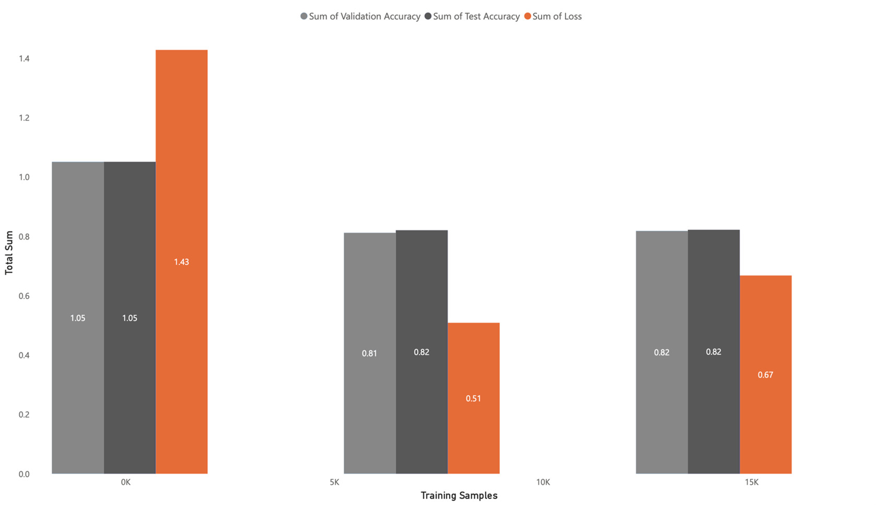

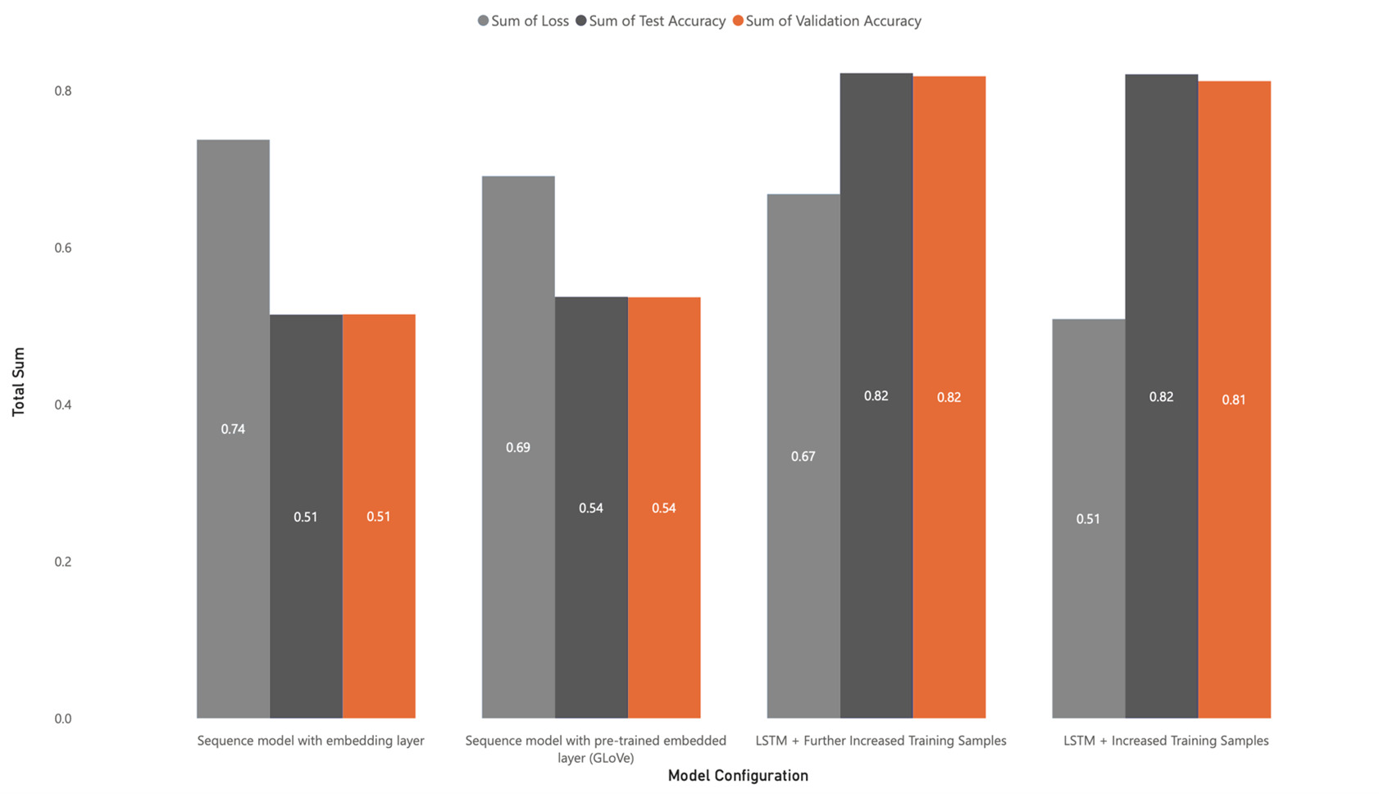

**Storyline/Recommendation**:

• Increasing Results with More Data: Our research demonstrates how much more data can be collected to improve the accuracy of sentiment analysis derived from movie reviews. We found that as we added more reviews to our dataset, our models got better at properly identifying the sentiments that were stated in the reviews. This emphasizes how crucial it is to use a wealth of data resources to improve and enhance model performance.   
  
• Learning by Doing: The improvements we made during the project highlight how crucial iterative experimentation and adaptation are to getting better outcomes. Through constant experimentation with various strategies and iterative refinement of our methods, we were able to gradually improve the predictive power of our models. This iterative learning approach highlights how crucial flexibility and agility are to data science projects. encouraging us to keep looking for new approaches and improving our techniques in order to optimize model performance.   
  
• Future Steps and Practical Applications: To keep enhancing performance, we'll be concentrating on growing our dataset and investigating cutting-edge model designs. Using progressively larger datasets and advanced model experiments, we hope to extract additional insights about people's attitudes from textual data. These improved models have a great deal of potential for practical uses, especially when it comes to helping companies better understand how customers feel about their goods and services. This will enable them to make more informed decisions and achieve financial success.